Use case and sequence diagrams for management system

Made by: Noel Didini

**Use Case Diagram**

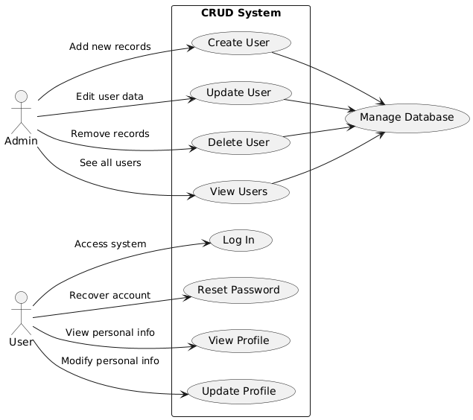

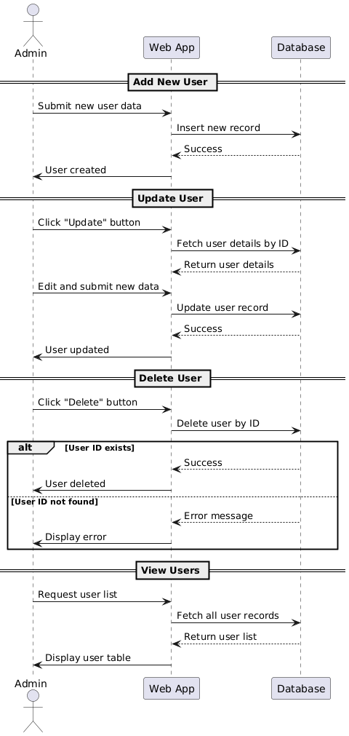

**Sequence Diagram**

**(For CRUD Operations)**

(**User Authentication and Profile Management)**